Fofa：app="MAiPU-无线控制器"
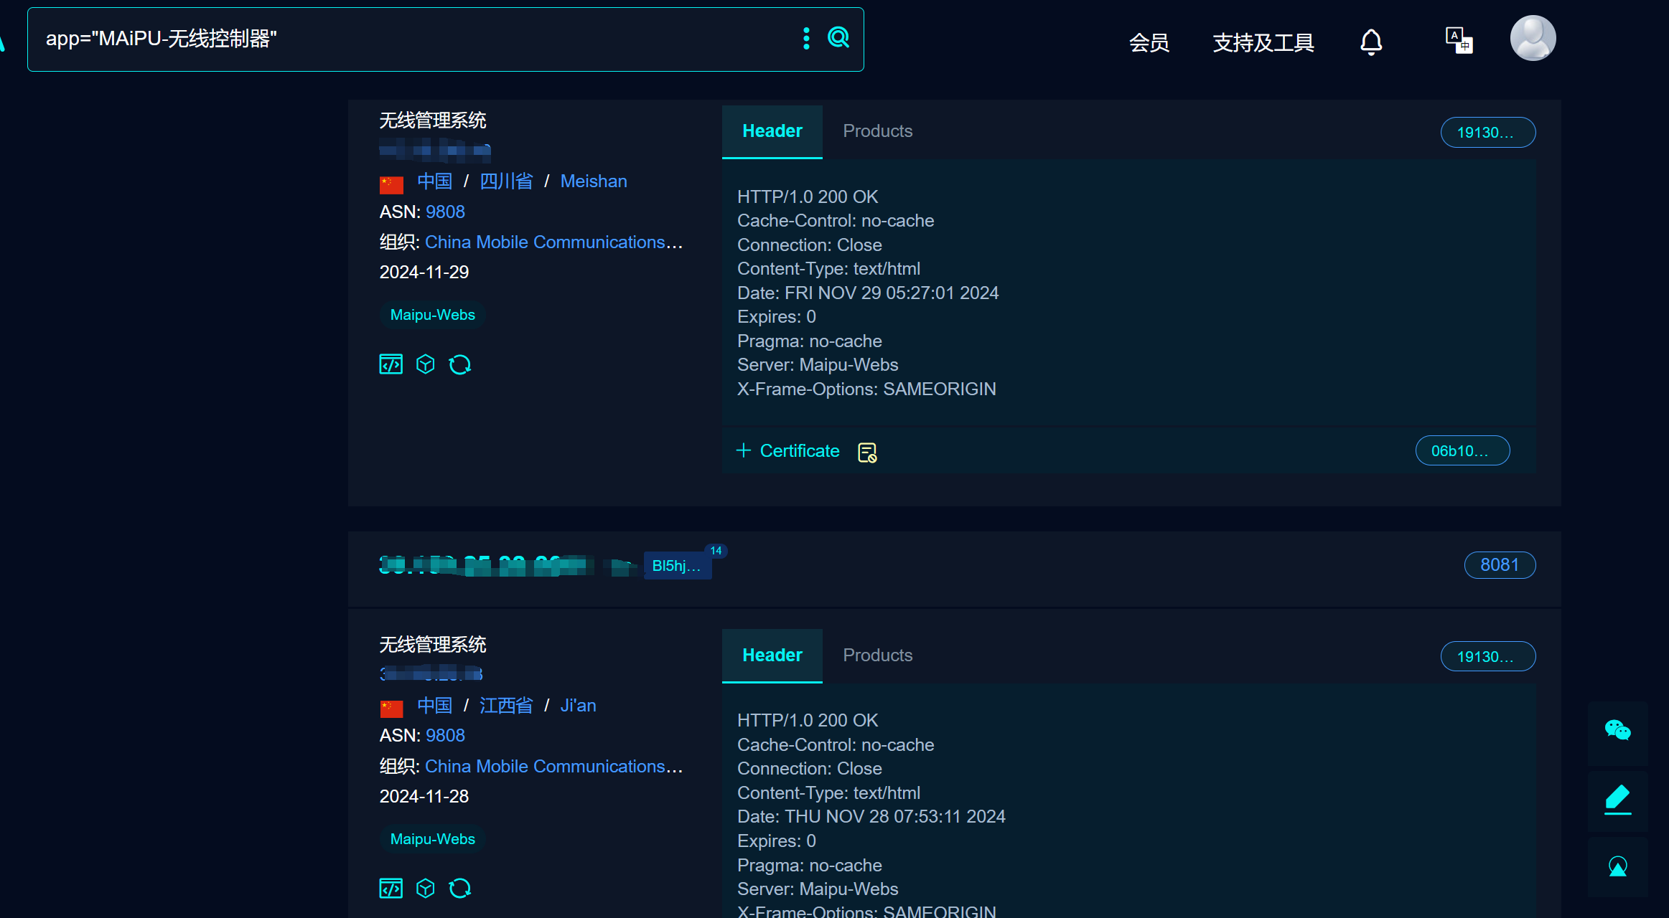


Version：software version>V6

Through the vulnerability interface, a malicious packet is constructed, mode enters the enable mode of the device, the number of commands executed by cmdnum command1 The commands to be executed
through this interface：/EXCU_SHELL

